SPARK: Simple Play Adaptations to Reference for Kids

Choice Board Trifold
Description: | Image:
The self-standing Choice Board Trifold is made of VELTEX® Brand loop-fabric. It can be stored flat and/or folds into a triangular position with hook and loop closure. It is two-sided to allow for six, usable 4 inch x 16 inch surfaces if folded, or two 12 x 16 surfaces if used flat. Visual supports can be prepared ahead and switched between surfaces for quick transitions between activities. The versatility of the board surfaces suggests the Choice Board Trifold can also be used for picture schedules or a simple communication board display. | 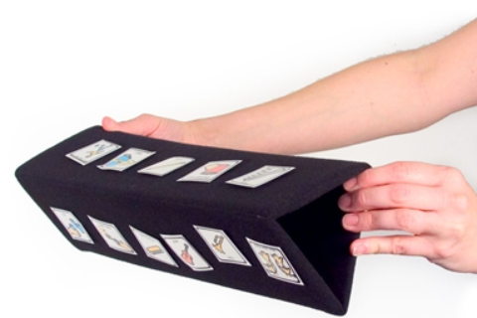  Purchasing Information  Demo Video

Who Might Benefit?
Those who…
• Have difficulty understanding only oral directions given by others.
• Have difficulty completing multi-step activities (schedules, routines, directions).
• May need additional support to indicate needs or choices.
Why Use?
Provides an opportunity to…
• Make choices.
• Follow directions with a minimum of verbal prompts.
• View pictures to support following schedules, routines, and adult directions.
• Build independence in following schedules, routines, and adult directions.
• Use a simple form of communication by pointing at visuals attached to the board.
Instructions for Use: | Adaptation Ideas:
Environmental Considerations  - Easily use in almost any environment because of the small size, weight, and easy transportability.  Positioning  - Use in most any position due to the size, portability, and minimal weight. It can be used on a table top, placed on the floor, positioned on a slant board, etc. A child could use it in positions such as sitting, standing, prone (Tummy Time position), supine (laying on their back), kneeling, etc.  Alternate Positioning  - Use flat or fold into triangle.  - Position vertically to view visual symbols as a list.  Basic Play/Use  - Instruction: Display choices, directions, communication supports, or sequences (such as what to put on before going outside or what's next on the schedule).  - Communication: Provide simple means of requesting, commenting or showing choices in the form of real objects, photos, or symbols.  - Classroom management: Use a choice making displays or as teaching prompts.  - Support Self Care Skills: Provide sequenced symbols relating to self-care routines such as unpacking a backpack or handwashing.  Extended Play/Use  - Use during story time to display symbols of characters or sequence of events. | Optional Additional Materials/Supplies  - Velcro  - Dycem  - Cardboard or sheets of corrugated plastic (available on Amazon or in hardware stores in the garage sale sign section)  - Velcro sensitive fabric  Build It Up  - Use physical objects in place of picture cards.  Stabilize It  - Velcro to various surfaces in the environment as needed so that it does not shift while the child is attempting to access it.  Add Sensory Cues  - Consider using high contrast visuals and/or contrasting background.  - Sensory cues such as puffy stickers, puffy paints, and different textures could be added to visuals.  Alternative Uses  - Use as a story-telling board when folded flat.  DIY Alternatives  - A simple trifold board can be made by folding cardstock into three sides and taping.  - A sturdy version of a trifold display board can be created from cardboard (https://www.simplyspecialed.com/velcro-board-for-special-education/) and covered with Velcro sensitive material.  - Corrugated plastic can be used to form a trifold display board.  - How to create low tech communication pictures;  - Examples of good high contrast color schemes for low vision and why they are important.

Additional Considerations:
- Research has shown that early use of a communication device does not impact a child’s ability to develop oral speech later and will actually often help to enhance development of oral speech. See: Beyond Spoken Words :Augmentative and Alternative Communication (AAC).

Words to Encourage Play/Use
Which one?  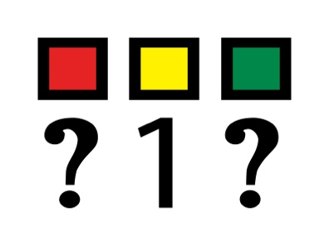 | Done  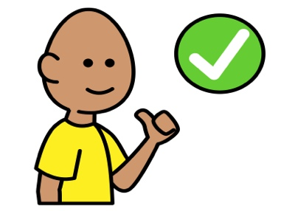 | Wait  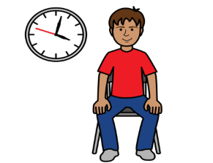
What do you want next? 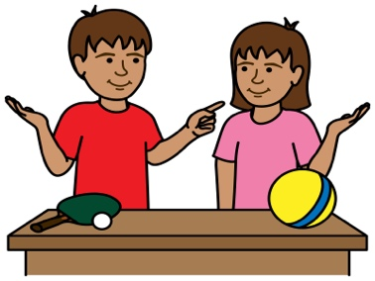 | Show me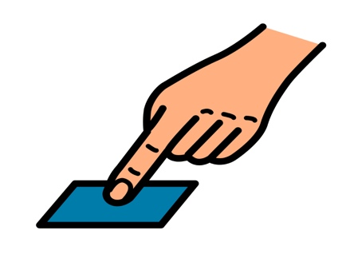 | Help  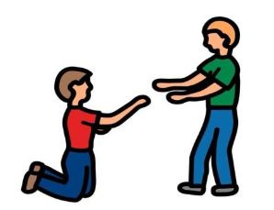
What’s next?  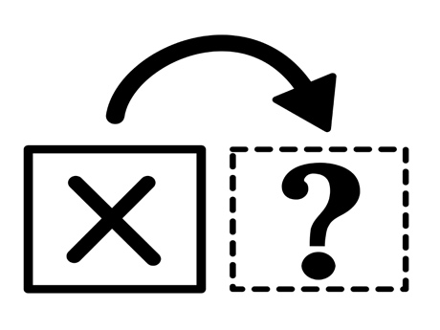 | Then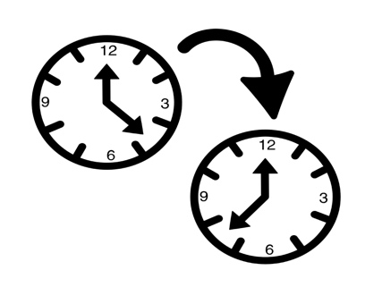 | Next  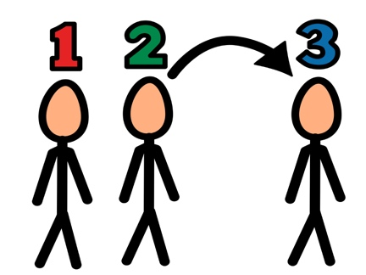
*”Adaptations” adapted from: Haugen’s Modes for Adapting Toys based on materials from the "Let's Play" Project at the University of Buffalo
PCS is a trademark of Tobii Dynavox, LLC. All rights reserved. Used with permission.

